**טכנולוגיות אינטרנט מתקדמות – תרגיל בית 1**

**קישור GIT :** [**LINK**](https://github.com/TRiZKy/WebCourse)

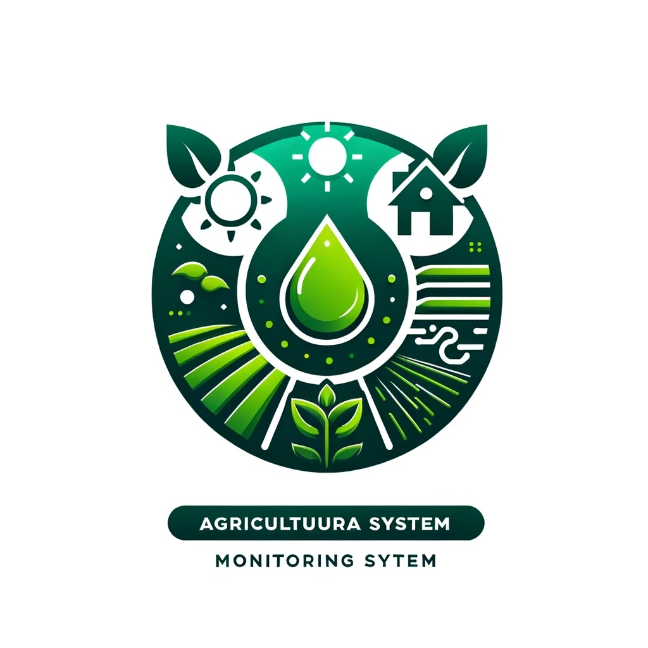

חברי הצוות :

|  |  |  |
| --- | --- | --- |
| 1. | אבישי בר | 316165984 |
| 2. | רון בנדל | 207285099 |
| 3. | שי ביסטריצקי | 206622086 |
| 4. | ינון לוי | 314628579 |

**חלוקת עבודה צוותית**

מהנדס מערכת : רון בנדל

|  |  |  |
| --- | --- | --- |
| שם חבר הצוות | משימות שהוקצו | משימות שהושלמו |
| רון בנדל | כתיבת דרישות פונקציונאליות  יצירת דף דשבורד | כתיבת דרישות פונקציונאליות  יצירת דף דשבורד |
| שי ביסטריצקי | כתיבת דרישות לא פונקציונאליות  יצירת תשתית בסיסית לעבודה | כתיבת דרישות לא פונקציונאליות  יצירת תשתית בסיסית לעבודה |
| ינון לוי | יצירת דף כניסה למערכת  יצירת לוגו לפרויקט | יצירת דף כניסה למערכת  יצירת לוגו לפרויקט |
| אבישי בר | בחירת נושא לפרויקט  יצירת דף הגדרות | בחירת נושא לפרויקט  יצירת דף הגדרות |

**דרישות**

Functional Requirements (FR)

1. The system shall allow farmers to register and login for users.
2. The system shall provide an overview of soil moisture, crop health, and weather conditions.
3. The system shall provide real-time monitoring of soil moisture levels.
4. The system shall analyze and display crop health data using IoT sensors or external sources.
5. The system shall integrate weather data from external sources.
6. The system shall send notifications and alerts for abnormal.
7. The system shall allow users to view and analyze historical data.
8. The system shall generate reports and analytics for soil moisture, crop health, and weather conditions.
9. The system shall allow users to export data in CSV and PDF formats.
10. The system shall represent data graphically through charts and graphs.
11. The system shall allow users to map their fields and visualize sensor data geographically.
12. The system shall synchronize data from multiple sensors.

Non-Functional Requirements (NFR)

1. Accessibility : The system shall ensure full accessibility on mobile devices, providing features such as scalable text, voice commands, and touch-friendly navigation to accommodate all users, including those with disabilities.
2. Configuration Management : The system shall support configuration management to track and control changes in the system.
3. Conformance : The system shall conform to industry standards and protocols for IoT and web applications.
4. Data Integrity : The system shall ensure data integrity through validation checks and error correction mechanisms.
5. Deployment : The system shall support automated deployment processes to ensure consistency and reduce downtime.
6. Development Environment : The development environment shall support version control, continuous integration, and automated testing.
7. Efficiency : The system shall be optimized for efficient resource consumption, ensuring minimal CPU and memory usage under load.
8. Effectiveness : The system shall deliver accurate and timely data to users, enhancing their decision-making capabilities.
9. Emotional Factors : The system shall have an engaging user interface with a modern design that provides a positive user experience
10. Extensibility : The system shall be designed to easily add new features and functionalities.
11. Flexibility : The system shall be flexible enough to adapt to future changes in requirements without significant rework.
12. Management : The system shall provide tools for effective management and monitoring of system operations.
13. Operability : The system shall be operable by users with minimal training.
14. Quality : The system shall deliver high quality, with minimal defects and high user satisfaction.
15. Throughput : The system shall handle high throughput, processing large amounts of data efficiently.
16. Usability : The system shall support both light and dark modes, allowing users to switch between themes based on their preference or environmental lighting conditions.